**SPRING BOOT TESTING TUTORIAL**

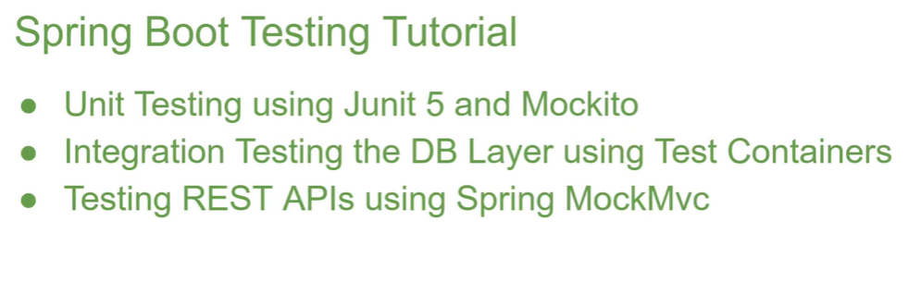

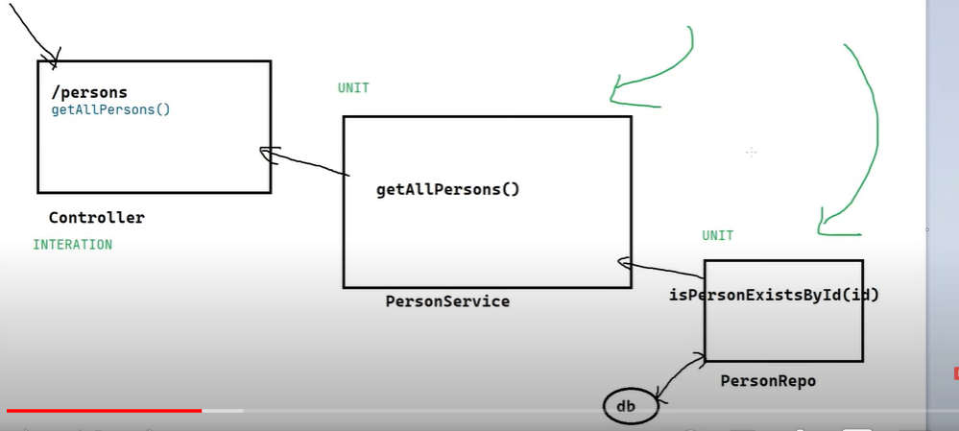

**Service and Repo ki unit testing or controller ki integration testing hoti hai.**